Study in Dynamic China: An Athletic and Cultural Competition of International Students

This is a national activity open to all international students who are studying at universities all over China. The organizer, the Ministry of Education, P.R.C. hopes to build up a golden bridge of friendship and exchange between China and the world, as well as attracting more international students to study in China. As a part of this national activity, Zhejiang Provincial Education Bureau will hold a selective tryout and the winners will have opportunities to participate in the national competition.

Here is some information about the selective tryout.

Organizer:
Zhejiang Provincial Education Bureau
Zhejiang Provincial College Students Physical Education Committee
Zhejiang Provincial Committee of International Students Education
Zhejiang University of Technology (ZUT)

Contents:
The competition is divided into 3 parts:

Sports Competition (50% of the total score)

- Campus Orienteering (20% of the total score)
The team consists of 6 students, in which 1 Chinese female student is a must.
Time: Mar. 4th, 15:00
Place: Ping Feng campus of ZUT
Individual Winner: the first 12 students will be issued a certificate
Team winner

- 6-person Basketball Game(10% of the total score)
Time: Mar. 5th
Place: Ping Feng campus of ZUT, the basketball court (if it’s raining, move to the indoor one)
Each team consists of 4 person, including 3 international students and 1 Chinese student.
Only male students
No registered basketball club members is allowed to participate.

- Team Aerobics (10% of the total score)
Time: Mar. 6th, AM
Place: Ping Feng campus of ZUT, the sports field
Each team consist of 3 male and 3 female international students.
Time limit: 5 minutes
- Chinese traditional ethnic sports (8 person with 9 feet racing) (10% of the total score)
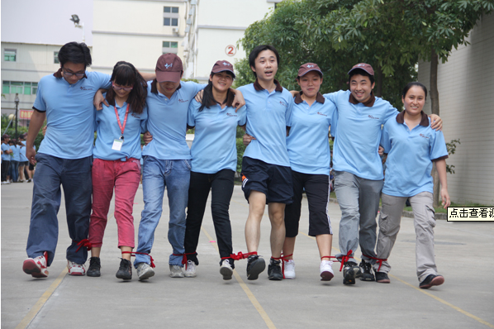
Time: Mar.6th, PM
Place: Ping Feng campus of ZUT, sports field
All team members join this part. The team who is fastest wins.

Talents Show (30% of the total score)

You can choose any of the following talent shows which are full of Chinese cultural or Zhejiang local cultural characteristics. The talent will only be showed in the form of individual rather than group state.
Time: Mar. 8th
Place: Ping Feng campus of ZUT, the big hall of the stadium
Only 2 members of each team will participate in this program, each one will show his/her talent within no more than 4 minutes.
- Chinese calligraphy
- Chinese poem reading
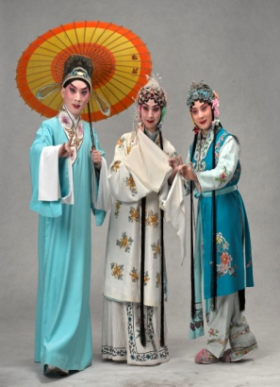
- Painting
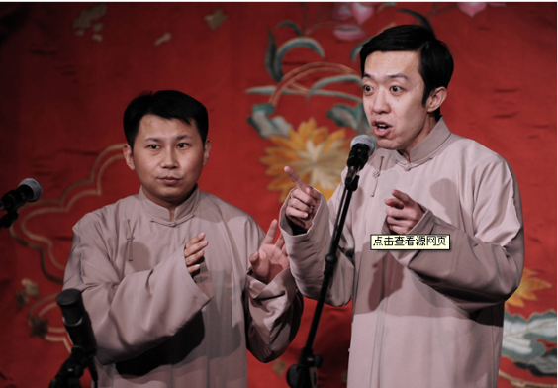
- Paper cutting
- Martial art
- Singing
- Music
- Short play
- Cross-talk
- Dancing
- Folk art
- Acrobatics
- Instrument

Chinese Cultural Knowledge Quiz (20% of the total score)

Time: Mar. 7th
Place: Ping Feng campus of ZUT, the big hall of the stadium
Each team recommends 2 international students to answer the questions. The questions are about Chinese history, geography, humanity and Zhejiang local culture.
The questions are divided into 3 parts: Compulsory answer questions, Selective answer questions and Preemptive answer questions.

Participants:
All Chinese and international students who are studying at the universities in Zhejiang Province are eligible to sign up this activity.
Each university organizes only 1 team, which consists of 10 students, 5 males and 5 females. The international students shall come from at least 2 countries, and the ratio of international students and Chinese students is 4:1.

Time Arrangement:
Sign up before: Jan. 20th, 2013
Formal Competition: March 4th ~8th, 2013

Awards:
For each part, the judges will give the score on the spot. The team whose final total score ranks among the first 5 will be awarded the trophy cup and certificate, and will participate in the national competition representing Zhejiang Province.

Application Form
Name | Campus Orienteering | Basketball Game | Aerobics | Talent Show | Quiz | Mobile Phone

Please tick appropriate box that you are interested.
Please note that the university will report the names to the Provincial Education Bureau before Jan. 20th, 2013. So please send this application form to me before Jan. 15th. Thanks!

